‘Raising the Standard – an inquiry of the Procedure Committee of the House of Representatives’

Pauline Cullen

Introduction
This paper discusses the Standing Committee on Procedure’s (Procedure committee) inquiry into Recommendations 10 and 27 of the Set the standard report: Report on the Independent Review into Commonwealth Parliamentary Workplaces (Set the standard report). The Independent Review into Commonwealth Parliamentary Workplaces was conducted by Australia’s Sex Discrimination Commissioner, Kate Jenkins per section 11 of the Australian Human Rights Commission Act 1986 in 2021. The aim of the review was ‘…to ensure all Commonwealth Parliamentary Workplaces are safe and respectful and that our national Parliament reflects best practice in the prevention and handling of bullying, sexual harassment and sexual assault’.
The paper begins by describing the environment that led to the establishment of the Independent Review into Commonwealth Parliamentary Workplaces by the Australian Government, with support from the Opposition and crossbench. The paper then explains the role of the Procedure committee, explores the inquiry process, evidence received, and recommendations made. Finally, the paper will explore recent developments in Parliament since the report was presented including the response by the Government to the report and later actions.
The lead-up to the Jenkins Review
While not the direct focus of this presentation and paper, there were a series of events and movements which led to the establishment of the review including the #MeToo movement and the subsequent Respect@Work: Sexual Harassment National Inquiry Report, commissioned in 2018 and released in 2020. As well, there were a series of highly publicised news stories which culminated in February 2021 when a young staffer made an allegation of rape taking place within Parliament House.
Foster Review
The day after the allegation of a rape in Parliament House, the Prime Minister Scott Morrison commissioned a review of procedures for reporting and responding to ‘serious incidents that occur during parliamentary employment’ to be undertaken by the Department of Prime Minister and Cabinet. The review, conducted by the Deputy Secretary, Ms Stephanie Foster, provided short-term recommendations based on its assessment of the processes and services available during and following serious incidents in Parliamentary workplaces.
The review was released on the 24 May 2021. It found that the support services and reporting processes available at the time were inadequate and provided several recommendations to address these issues in the short-term. The review acknowledged the need for longer-term, systemic cultural reform and identified the Jenkins review as the mechanism for beginning this change.
Gaetjens Review
The day after the announcement of the Foster review, on 17 February, the Prime Minister announced that the Secretary of the Department of Prime Minister and Cabinet, Mr Phil Gaetjens, would also conduct a review. This review’s goal would be to ‘verify the advice the Prime Minister has received from his Office about when his staff became aware of the alleged sexual assault at Parliament House’. However, in March 2021 Mr Gaetjens told a Senate hearing that the inquiry had been suspended until criminal proceedings related to the alleged sexual assault had been finalised. In August 2021 the inquiry was suspended for a second time for the same reasons.
March 4 Justice
Ten days after the announcement of the Jenkins review, thousands of women gathered on the lawns of Parliament House as part of the women’s March 4 Justice rally. Rally organisers called for gender equality and justice for victims of sexual assault and rallies which occurred in many cities around the country, demonstrated mounting pressure on the government to create change. While the Jenkins review had already been announced, the march focused attention on the government’s and others response to incidents that had occurred in recent months and years.
‘Set the Standard Report’
On 5 March 2021, the Independent Review into Commonwealth Parliamentary Workplaces was announced. The review was to be conducted by the Australian Human Rights Commission, who also conducted the Respect@Work review in 2020. The Australian Human Rights Commission is an independent organisation established by legislation and is Australia’s leading Human Rights Institution. The review was to be conducted by the Sex Discrimination Commissioner, Ms Kate Jenkins. As well, the government introduced the Archives and Other Legislation Amendment Bill 2021, in mid-March 2021 to ensure that the right of access under the Freedom of Information Act 1982 was excluded for all documents provided to or created by the independent review. It also provided that these records would not come into the open access period under the Archives Act 1983 until 99 years after the record comes into existence. When the bill was introduced into the House, the Minister during the second reading speech explained:
The amendments are intended to encourage individuals to come forward to the independent review and give information that is relevant to its terms of reference. This information could include accounts of a deeply personal and sensitive nature as well as allegations about the conduct of other people.
The review was conducted over most of 2021, with a progress report released in July 2021. The final report, Set the Standard: Report on the Independent Review into Commonwealth Parliamentary Workplaces was presented to the Attorney-General on 30 November 2021. The review heard from 1723 individuals, 33 organisations and collectives with 935 survey responses, 490 interviews, 302 written submissions and 11 focus groups.
The Set the Standard report noted that it occurred at a:
…critical moment in time. It has been conducted in the context of shifts in community expectations around equality, safety and respect.
The findings of the Set the Standard Report found that 37 per cent of people currently working in Parliament had experienced some form of bullying in these workplaces and 33 per cent had experienced sexual harassment. The report also noted that these experiences had an impact on people as a result, impacting their mental and physical health, confidence and ability to do their job as well as their future career. The report made 28 separate recommendations which were wide ranging and set out a framework for action to ensure that Commonwealth Parliamentary Workplaces are ‘safe and respectful, uphold the standing of the Parliament and are a worthy reflection of the community that they serve.’
The report made 28 recommendations in a framework for action in areas of:
- leadership,
- diversity, equality and inclusion,
- systems to support performance,
- standards, reporting and accountability and
- safety and wellbeing.
The most relevant recommendations in total to the Standing Committee on Procedure were recommendations 10 and 27 which were within the
- diversity, equality and inclusion area and
Recommendation 10: Everyday respect in the parliamentary chambers
The Presiding Officers should review the Standing Orders and unwritten parliamentary conventions, including their application in practice, with a view to:
(a) eliminating language, behaviour and practices that are sexist or otherwise exclusionary and discriminatory
(b) improving safety and respect in the parliamentary chambers.
- the safety and wellbeing area.
Recommendation 27: Review of Parliamentary sitting calendar and Order/Routine of Business
The Procedure Committees of the House of Representatives and the Senate should review the Parliamentary sitting calendar and the Order/Routine of Business with a view to enhancing wellbeing, balance and flexibility for parliamentarians and workers in Commonwealth parliamentary workplaces.
The Standing Committee on Procedure
The Standing Committee on Procedure (the committee) is a domestic committee of the House of Representatives which is established by Standing Order 221 to inquire into and report on the practices and procedures of the House and its committees. It was first established in 1985 to replace the Standing Order Committee. Each parliament it undertakes an inquiry into the maintenance of the standing orders (and sessional orders if appropriate) as well as undertaking other inquiries which are relevant to its mandate. These have included looking at Question time, petitions, the opening of Parliament and options for nursing mothers.
The Inquiry
The committee resolved, under its powers of self-referral, to undertake an inquiry into the two recommendations listed above. The inquiry commenced in September 2022, following the commencement of the 47th Parliament on 26 July 2022. The committee explained via its initial media release that it was inquiring into:
… whether there were opportunities to improve both the standing orders and any unwritten conventions in the Chamber,’ the Chair of the committee, Hon Shayne Neumann, said. ‘The committee is interested in feedback and is now welcoming submissions to the inquiry.’
However, matters such as codes of conduct and behaviour outside the Chamber are covered by other recommendations and will not be considered as part of this inquiry.
As a domestic committee the committee often has a narrower focus and tends to receive submissions from internal stakeholders particularly in relation to its usual maintenance of the standing orders inquiry. For this inquiry the call for submissions was targeted and the committee received a total of eight submissions with two of them from external submitters and the remaining ones from members of parliament including the Speaker of the House, the Leader of the House and the Manager of Opposition Business as well as the Clerk of the House. The committee held private briefings with parliamentary office holders, the Clerk and parliamentary colleagues in other jurisdictions and also met privately with the Sex Discrimination Commissioner, Ms Kate Jenkins in the early stages of the inquiry. The committee held four public hearings including two roundtables with former Speakers and invited academics. The other two hearings featured Dr Sonya Palmieri, an expert in gender-sensitive parliaments and Ms Kate Jenkins.
Recommendation 10
When considering recommendation 10 the Committee considered the current standing orders and the existing sanctions available to the Speaker, what practice and procedure documents exist in other jurisdictions and training materials, both in terms of availability and relevance. They also considered evidence received in submissions and from public hearings.
The focus for the committee was identifying potential changes to the standing orders that could help eliminate language, behaviour and practices that are sexist or otherwise exclusionary and discriminatory. There are currently nine standing orders (standing orders 88 to 96) which relate to disorder, detail the behaviours that are considered disorderly and outline the actions which are available to the Speaker or the occupant of the Chair to enforce order in the House.
There was a range of evidence received in relation to this, which framed the discussion around whether more explicit information was required in the standing order. In the evidence received there were suggestions about what form, if any, the changes to the standing orders could take. The committee examined the role of the Speaker in managing language and behaviour in the Chamber, considering the powers of standing order 92, which empowers the Speaker to intervene when a Member’s conduct is considered offensive or disorderly. The question as to whether certain words needed to be specified as being offensive was explored as was the importance of the parliament as a forum for robust debate. The committee also reflected on remarks being directed through the Speaker and also references to Members.
At the public hearings, witnesses were questioned about what they considered would be appropriate changes to the standing orders to increase everyday respect in the Chamber. The committee was fortunate to hear from three former Speakers of the House of Representatives, Ms Anna Burke AO, Mr Harry Jenkins AO and the Hon Peter Slipper who provided a unique perspective of their experience being in the chair and what they saw as the role of the Speaker, in the management of the Chamber. As well, the committee heard from academics and a former Victorian Legislative Assembly member and Speaker who participated in a roundtable discussion.
The committee reinforced the importance of robust debate and that the Chamber should always be a forum for the frank exchange of ideas but noted that the use of offensive language or disorderly conduct such as acts of bullying or sexual harassment have never been acceptable. The committee noted that the authority of the Speaker meant that they could continue to rule on offensive language ‘based on the context in which it is used and community and parliamentary standards.’ The committee concluded that changes to the standing orders to make it clear that sexist, racist, homophobic or otherwise exclusionary language is offensive would strengthen the Speaker’s ability and recommended that standing order 89 be amended.
In relation to how the House could respond to unparliamentary language and behaviour the committee considered the use of sanctions. Standing orders 94 to 96 outline existing sanctions which include that a member can be directed to leave the chamber for one hour under standing order 94(a). The direction is not open for debate or dissent and House of Representatives Practice notes that if a Member does not leave the chamber immediately or continues to act in a disorderly manner, they may be named. Naming of a member is provided for under standing order 94(b). When a Member is named by the Speaker, a motion for the Member to be suspended from the service of the House may be moved and must be resolved without amendment, adjournment or debate. There is an increasing scale of time that the Member is suspended for they are suspended multiple times in the one calendar year.
The committee had previously considered increased sanctions when it undertook an inquiry into the practices and procedures relating to Question Time, where they suggested that standing order 94(a) be amended as such:
The Committee recommends that the House amend standing order 94 so that the Speaker can direct a Member who is disorderly during Question Time to leave the Chamber for a period of either one or three hours (on an escalating basis) to be served during Question Time and the discussion of a matter of public importance.
This recommendation was not accepted by the Government at the time.
The committee explored the idea of increasing sanctions, with evidence suggesting that the one-hour penalty was not a sufficient deterrent to poor behaviour. Former Speakers noted that an option between the one-hour and being named would assist the Speaker in maintaining order. The committee explored existing practice and procedure in other parliaments, with there being some variation in the penalty or period of suspension.
The view of the committee was that the current sanctions against disorder were not sufficient and not enough of a deterrent and recommended the amendment of standing order 94(a) to allow the Speaker to direct a disorderly Member to leave the Chamber for a period of either one or three hours at the discretion of the Chair, increasing in severity for disorderly conduct that has continued or escalated. The committee also recommended that this should have more general application and not be restricted to Question Time and the matter of public importance, as recommended in the previous Question Time report.
The committee also considered awareness, guidance materials and training, receiving evidence that training can change awareness and recognition of behaviours as they happen. They stated that they expected that Member were aware of ‘their obligations to behave respectfully and not to use offensive language against other Members or objectionable words in the Chamber.’
They recommended that the Department of the House of Representatives review guidance and training materials available to Members to ensure that Members are aware that:
- words that are sexist, racist, homophobic and otherwise exclusionary or discriminatory are considered offensive words under standing order 89,
- disorderly conduct under standing order 91 includes acts of bullying and sexual harassment in the Chamber, and
- under standing order 92(b), a Member may draw the Speaker’s attention to the conduct of a Member.
They also recommended that any changes to standing orders as a result of the Procedure Committee’s report is reflected in guidance for members of the Speaker’s Panel and for chairs and deputy chairs of parliamentary committees.
Recommendation 27
The second recommendation related to the sitting calendar and order of business which was in the safety and wellbeing area of the Set the Standard report, with a view to enhancing wellbeing, balance and flexibility for parliamentarians and workers in Commonwealth parliamentary workplaces.
The Committee considered the sitting calendar, the hours of sitting and other provisions for improving the flexibility and ‘family friendliness’ of the Chamber.
Standing order 29 which relates to set meeting and adjournment times notes that the House shall meet each year in accordance with the program of sittings for that year agreed to by the House, unless otherwise ordered and subject to standing order 30.
The committee found that in general, the House of Representatives now meets and adjourns considerably earlier than it has in the past but since 1984, the total time spent sitting in a single week has not increased or decreased to any significant level.
The committee heard a range of views in relation to what is the best pattern of hours of sitting and days. The committee heard that the experience of Members who have regional or remote electorates is quite different to Members who live closer and the amount of travel time to return to electorates does impact some Members more than others.
In his submission, the Leader of the House, the Hon Tony Burke MP provided details of the changes to the Order of Business agreed on the second sitting day of the 47th Parliament to ‘make hours of sitting more suitable for parliamentarians with family and/or caring responsibilities.’ These involved amendments to standing orders 50 and 133, which provide for deferred divisions after 6.30pm on Monday, Tuesday or Wednesday, allowing Members with family or caring responsibilities to leave Parliament after 6.30pm, while still providing for debate on government business to continue until the usual time of 7.30pm. There was also changes to standing orders 82 and 85, for urgent bills which allows for expedited debate and passage of urgent legislation by extending sitting hours but deferring divisions until the following morning. A supplementary submission explored the impact of the various models of debate management motions in the first six months of the Parliament, where motions were moved to suspend standing and sessional orders to alter the duration and structure of the debate on bills.
There was general agreement in evidence that sittings should not take place during school holidays however the committee did not consider that this needed to be made explicit in the standing orders.
The committee also considered the wider perspective beyond Members, of Members’ staff and parliamentary staff of the hours of sitting. The Clerk of the House noted that the changes at the start of the 47th Parliament meant that Members did not need to remain in Parliament House for divisions or quorums, but this did not reduce the hours of parliamentary staff who support the operation of the House.
The committee noted that it would continue to monitor the effect of the changes introduced in the Parliament as part of its current inquiry into the maintenance of the standing orders and recommended that a future Procedure Committee review the days and hours of sitting.
The committee looked more broadly at ways that there could be changes to the unwritten parliamentary conventions, matters such as representation and other changes that may improve safety and respect. They received evidence which proposed increasing opportunities for discussion gender equality, diversity and inclusion and the creation of a parliamentary group or committee on gender equality, diversity and inclusion.
The committee noted that there were a range of opportunities for Members to speak on topics of their choosing during each sitting week but acknowledged that these opportunities were brief and because individual Members could choose what they wished to speak on would not encourage a full debate on a particular topic. They considered that the establishment of a House Standing Committee on Gender Equity, Diversity and Inclusion could provide a mechanism for scrutiny as well as a forum for debate and accordingly recommended that the House consider the establishment of a House Standing Committee on Gender Equality, Diversity and Inclusion.
They also explored whether diversity requirements should be mandated, for example, in the alternation of the call and in quorum requirements. The Clerk of the House noted that there could be unintended consequences to these if there were changes in the composition of the House.
The committee explored the idea of gender-neutral language in the standing orders, which the Set the Standard report noted already were considered gender-neutral. The standing orders were amended in 1994 to incorporate references to Members in gender-inclusive pronouns and to omit the term ‘chairman’ and substitute the term ‘chair’.
The committee noted that guidance in the form of drafting directions from the Office of Parliamentary Counsel at the time required masculine personal pronouns to always be accompanied by feminine personal pronouns except in the rare cases of legislation intended to apply to people of one sex but not the other such as maternity leave legislation.
The committee recognised the power of language and acknowledged that the standing orders could be made more inclusive by ‘replacing references to he or she and his or her with references to they, their and them.’ They recommended at the next major review of the standing orders, the House consider removing masculine and feminine pronouns from the standing orders and replacing them with neutral terms.
Report
The report was tabled on 7 August 2023 incorporating a dissenting report. It made six recommendations including:
- amending standing order 89 (recommendation 1),
- amending standing order 94(a) (recommendation 2),
- reviewing guidance material and training available to Members (recommendation 3),
- ensuring guidance for members of the Speakers’ Panel and chairs and deputy chairs of parliamentary committees (recommendation 4),
- considering establishing a House Standing Committee on Gender Equity, Diversity and Inclusion (recommendation 5) and
- during the next major review of the standing orders, considering removing masculine and feminine pronouns and replacing them with gender-neutral alternatives (recommendation 6).
The report provided a summary list of references to offensive or unparliamentary language in other jurisdictions as an appendix as well as a list of sanctions for disorder in other jurisdictions.
It was noted by the Chair of the committee during the report tabling speech that ‘The parliamentary chambers are unique work environments. Freedom of speech and the robust exchange of ideas are core principles of parliamentary democracy. But that doesn't mean that our debates shouldn't be respectful.’
The Deputy Chair in his tabling speech explained the Coalitions reasons for the dissenting report, where they stated that they rejected recommendation 5 and 6 and their reasons for doing so.
Responses to the Report
On 16 May 2024 following Question Time the Speaker presented his response to certain recommendations made in the Procedure Committees report. The Speaker responded to recommendation 3 and 4, agreeing to both.
The Leader of the House also presented the government response on 16 May 2024. The Government responded to all recommendations in the following manner:
Recommendation | Response
1 Amending SO 89 to add extra words | Noted, the Government considered that the existing prohibition of ‘offensive words’ applies to words which are sexist, racist, homophobic and/or otherwise exclusionary or discriminatory and also that it is ultimately the role of the Speaker to consider the nature of words used by a Member and the context to decide whether they are offensive or disorderly.
2 Amend SO 94(a) to add extra words | Accepted, the Government will bring forward amendments to standing order 94(a) consistent with this recommendation.
3 Dept of House of Representatives review the guidance material and training for Members | The Government noted that it was appropriate for the Speaker to respond to this recommendation as it is directed to the Department of the House of Representatives.
4 Speaker and the House of Representatives ensure guidance for members of Speaker’s Panel and chairs and deputy chairs of parliamentary committees | The Government noted that it was appropriate for the Speaker to respond to this recommendation as it is directed to the Department of the House of Representatives.
5 The House consider establishing a House Standing Committee on Gender Equality, Diversity and Inclusion | The Government noted this recommendation, and clarified that it was within the scope of existing House and Joint committees to take these matters into consideration in conducting their work
6 The House consider removing masculine and feminine pronouns from the standing orders and replacing them with gender-neutral alternatives. | The Government noted this recommendation.

Proposed notice of motion
On 3 July 2024, the government gave notice that they were proposing amendments to standing orders which included changes to standing order 94. The motion, which was presented with several other proposed changes to standing orders is yet to be moved in the House.
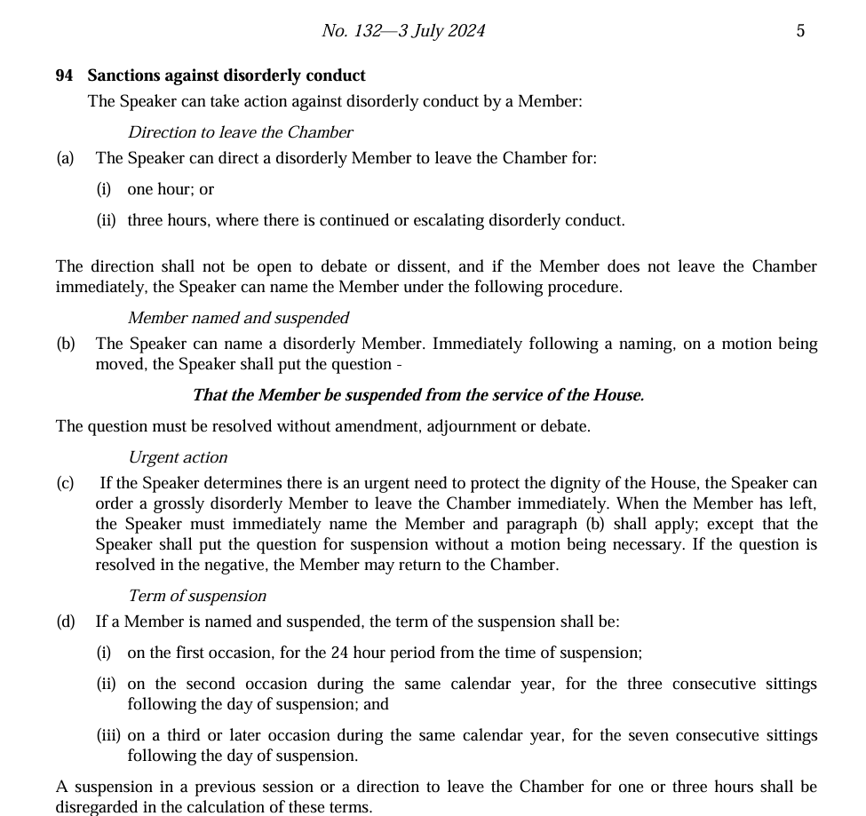

Australian Human Rights Commission, Terms of Reference - Independent Review into Commonwealth Parliamentary Workplaces, https://humanrights.gov.au/CPWReview (accessed 14 August 2024)
‘Set the Standard: Report on the Independent Review into Commonwealth Parliamentary Workplaces’ Australian Human Rights Commission, 30 November 2021, p. 8.
‘Respect@Work: National Inquiry into Sexual Harassment in Australian Workplaces’. Australian Human Rights Commission, 5 March 2020.
S. Maiden, ‘Young staffer Brittany Higgins says she was raped at Parliament House.’ News.com.au, 15 February 2021.
Toxic Parliaments, Sawyer and Maley, p. 102
‘Review of the Parliamentary Workplace: Responding to Serious Incidents.’ Department of Prime Minister and Cabinet, 24 May 2021
‘Review of the Parliamentary Workplace: Responding to Serious Incidents.’ Department of Prime Minister and Cabinet, 24 May 2021
K. Murphy and D. Hurst, ‘Head of PM’s department pauses inquiry into Brittany Higgins rape allegations over AFP concerns’. The Guardian, 22 March 2021
Senator the Hon S. Birmingham: Tabling of terms of reference for the Foster Review in the Senate, Senate Order for Production of Documents No. 1034
K. Murphy and D. Hurst, ‘Head of PM’s department pauses inquiry into Brittany Higgins rape allegations over AFP concerns’
J. Norman, ‘Gaetjens inquiry into who in Prime Minister's Office knew about Brittany Higgins' allegations of rape suspended’. ABC News, 30 August 2021
G. Hitch, ‘Brittany Higgins tells women's March 4 Justice rally in Canberra 'the system is broken'’. ABC News, 15 March 2021
Gorman, A, ‘Enough is enough! Where, when and why March 4 Justice protests are taking place across Australia,’ The Guardian, 15 March 2021
The Hon A. Hawke MP, Commonwealth, Parliamentary Debates, House of Representatives, 25 March 2021, p. 3594
The Hon A. Hawke MP, Commonwealth, Parliamentary Debates, House of Representatives, 25 March 2021, p. 3594
‘Set the Standard: Report on the Independent Review into Commonwealth Parliamentary Workplaces’ Australian Human Rights Commission, 30 November 2021
Set the Standard.’ Australian Human Rights Commission, p. 12
Set the Standard.’ Australian Human Rights Commission, p. 18
Set the Standard.’ Australian Human Rights Commission, p. 18.
Department of the House of Representatives, Parliament of Australia, ‘History of the Procedure Committee’. Accessed at https://www.aph.gov.au/Parliamentary_Business/Committees/House_of_Representatives_Committees?url=proc/history.htm
Standing Committee on Procedure Media release, Setting standards in the Chamber, 6 October 2022
Standing Committee on Procedure, Raising the Standard Inquiry into recommendations 10 and 27 of Set the Standard: Report on the Independent Review into Commonwealth Parliamentary Workplaces, (Raising the Standard) p. 19
House of Representatives Standing Orders 94, 95 and 96
House of Representatives Practice, 7th Edition, p. 536
Standing Committee on Procedure, A window on the House: Practices and procedures relating to Question Time, p. 88
Australian Government, Australian Government response to the House of Representatives Standing Committee on Procedure report: A window on the House: practices and procedures relating to Question Time, March 2022, p. [3]
Raising the Standard, Appendix E
Raising the Standard Report, p. 26
Raising the Standard Report, p. 32
Raising the Standard report p. 32
Keith Pitt MP, Procedure Committee Inquiry into Recommendations 10 and 27 of Set the Standard, Submission 5
Tony Burke MP, Leader of the House, Procedure Committee Inquiry into Recommendations 10 and 27 of Set the Standard, Submission 5, p.1
Tony Burke MP, Leader of the House, Procedure Committee Inquiry into Recommendations 10 and 27 of Set the Standard, Supplementary to Submission 3, p.1
Clerk of the House, Procedure Committee Inquiry into Recommendations 10 and 27 of Set the Standard, Submission 5, p. 1
Raising the Standard Report, p. 41
Raising the Standard Report p. 49
Raising the Standard Report p. 49
Raising the Standard Report p. xv and xvi
The Hon S. Neumann MP, Commonwealth, Parliamentary Debates, House of Representatives, 7 August 2023 p. 5684
Speaker’s Response – Raising the Standard, 16 May 2024

